**SUPER MATERIALS ONE MEMBER COMPANY LIMITED**187/7 Dien Bien Phu Street, Da Kao Ward, District 1, Ho Chi Minh City, Vietnam **T**. +84 98 9944 746 **|** **E**. info@ss-materials.com **|** **W**. www.ss-materials.com

*Ho Chi Minh City, Date 09 September 2019*

**BANK ACCOUNT INFORMATION**

|  |  |
| --- | --- |
| COMPANY NAME | SUPER MATERIALS ONE MEMBER COMPANY LIMITED |
|  |  |
| ADDRESS | 187/7 Dien Bien Phu Street, Da Kao Ward, District 1, Ho Chi Minh City, Vietnam |
|  |  |
| TAX CODE | 0315502282 |
|  |  |
| TEL. | +84 98 9944 746 |
|  |  |
| FAX | - |
|  |  |
| BENEFICIARY | SUPER MATERIALS ONE MEMBER COMPANY LIMITED |
|  |  |
| ACCOUNT NUMBER (VND) | 176474165 |
|  |  |
| SWIFT CODE | VPBKVNVX |
|  |  |
| BANK NAME | Vietnam Prosperity Joint Stock Commercial Bank |
|  |  |
| BRANCH  BANK ADDRESS | Le Van Viet  224A Le Van Viet Street, Tang Nhon Phu B Ward, District 9, Ho Chi Minh City, Vietnam |

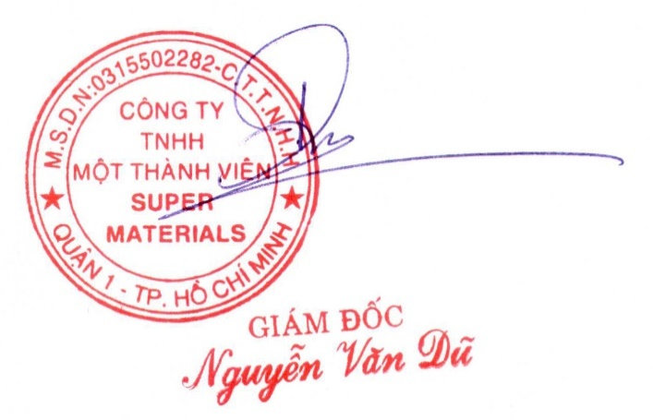  
Best Regards ./.